**FrontEnd of Stock Issue Form**

The Accounting is required to view the Stock Issue Forms to know what are the details of the Patient in terms of paying bills and to know who are in charge of the Stocks, prepared by and approved the forms.

Fill up the fields with the correct details.

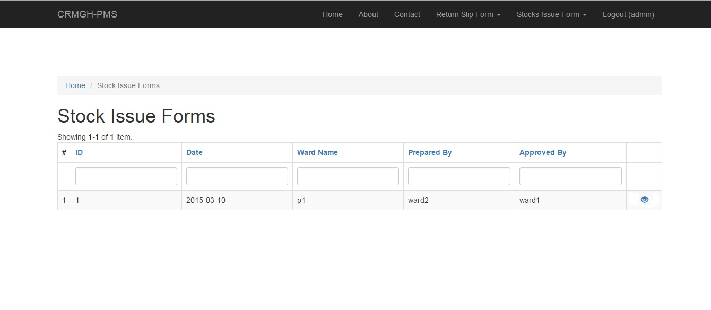

**FrontEnd of Stock Issue Item**

The Pharmacist is required to view the Stock Issue Items to know what are the Items, Quantity and the Expiration Date of the medicines that they needs.

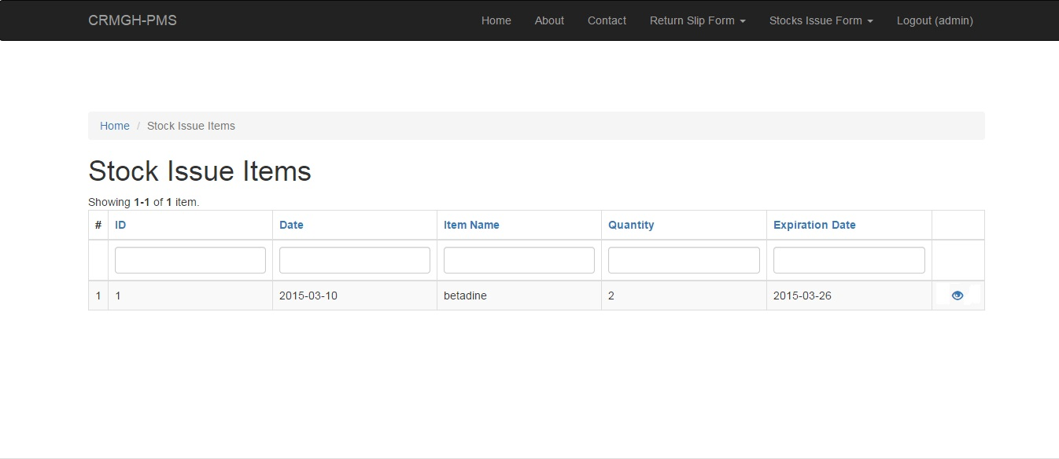

**BackEnd Stock Issue Form**

The Pharmacist can modify the following:

* Create
* View
* Update (If the Stocks need to be updated)
* Delete

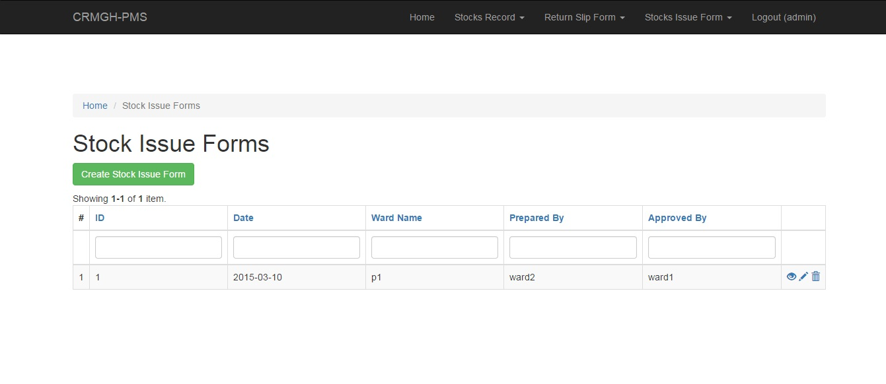

**BackEnd Stock Issue Item**

The Pharmacist can modify the following:

* Create
* View
* Update (If the Item needs to be updated)
* Delete

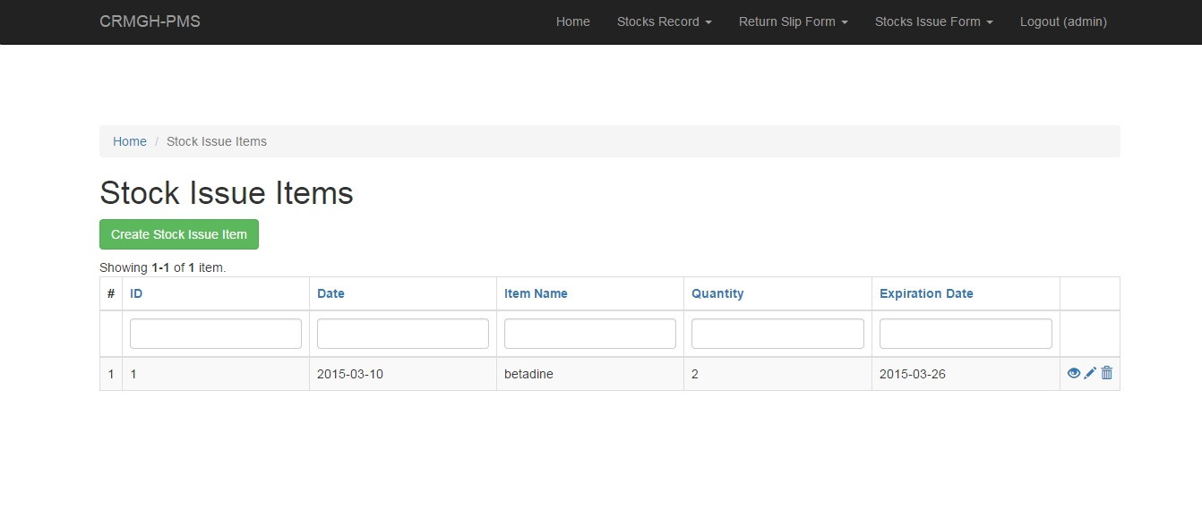

**Creating Stock Issue form**

Fill up the fields of the Following requirements:

1. ID number
2. Date when you fill up this form.
3. The ward name in charge
4. Prepared by:
5. Approved by:
6. Issued by:
7. User ID (If the Pharmacist or Accounting )

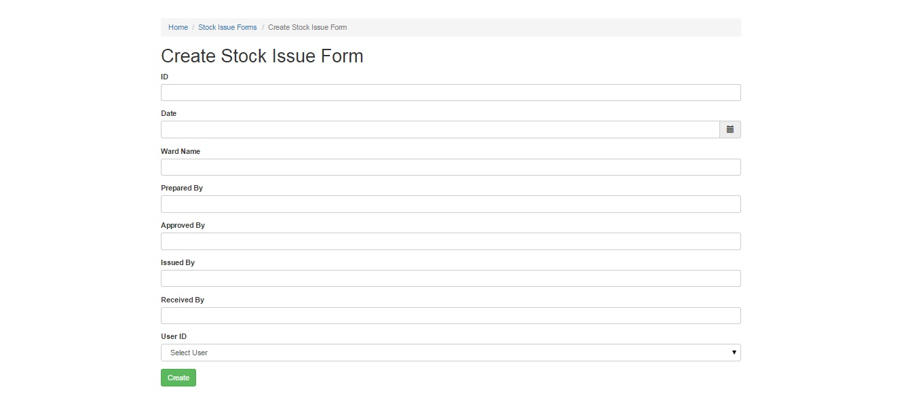

**Creating Stock Issue Item**

Fill up the blank fields to create Stock Issue item just click on the fields.

1. ID
2. The date today
3. Item name
4. Quantity
5. Expiration Date
6. Unit Cost
7. Amount
8. Remarks
9. Stock Issue Form ID (you need to fill up first the Stock Issue Form before the Stock Issue Item. )

